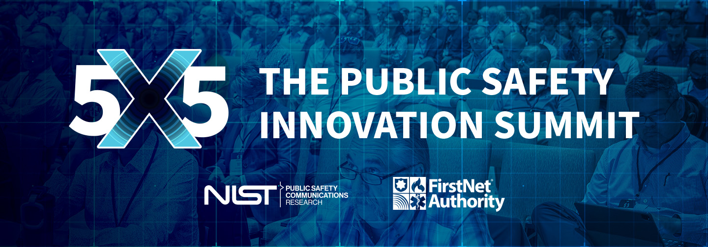

Subject: Request to Attend 5x5: The Public Safety Innovation Summit

Dear [SUPERVISOR’S NAME],

I am requesting approval to attend 5x5: The Public Safety Innovation Summit on June 3–5 in Bellevue, Washington. This three-day summit, hosted by the First Responder Network Authority (FirstNet Authority) and the National Institute of Standards and Technology’s Public Safety Communications Research Division (NIST PSCR), brings together leaders from public safety, industry, academia, and government to discuss practical solutions for emergency communications technology.

From live demos, keynotes, breakout sessions, and networking opportunities, attending 5x5 will give me the opportunity to explore the latest and greatest in emergency communications technology, discover new approaches to the problems our organization is working to solve, and create new connections with industry leaders.

By attending 5x5, I will:

**Explore new technology solutions and learn how to utilize them.**

The summit offers more than 70 live technology demonstrations, showcasing the latest advancements across various topics, such as mission critical services, situational awareness, public safety operations, and user interface/user experience. By attending, I will gain firsthand experience with the latest in public safety technology, including technology still in development and testing phases. I can even share feedback on how that technology should be implemented in emergency response scenarios.

**Hear problem-solving tips and lessons learned from public safety leaders and pioneers.**

5x5 offers dozens of keynotes, plenaries, and breakout sessions. I will have the opportunity to attend sessions pertaining specifically to our mission area, led by professionals and leaders in public safety communications, broadening my horizons for new solutions and opportunities. During deep-dive discussions, I can provide critical input highlighting challenges we face and inform future focus areas for NIST PSCR and the FirstNet Authority.

**Broaden my network of colleagues.**

Speakers at 5x5 come from a variety of different mission areas, such as industry, government, academia, and public safety. This diversity of perspectives will expand my knowledge and understanding of public safety communications technology. I will have time for one-on-one conversations with speakers, demo hosts, and representatives from the FirstNet Authority and NIST PSCR.

Upon returning from 5x5, I would be pleased to prepare a short presentation of what I have learned at 5x5 and provide copies of materials and contacts I have collected, such as handouts, flyers, and business cards, so our team can build on connections and expand awareness.

Thank you for your consideration. I look forward to discussing this opportunity with you!

[YOUR NAME]